

ASSIGNMENT-4

# PYTHON

# **NAME : MADA SRAGVIN KUMAR**

# **MIS NO : 112315097**

# **GROUP : 3**

**YEAR : 2**

**SECTION : A**

# **6b of assignment 3**

def merg_sort(a,p,q,r):

n1=q-p+1

n2=r-q

L=a[p:q+1]

R=a[q+1:r+1]

L.append(float('inf'))

R.append(float('inf'))

i=0

j=0

for k in range(p,r+1):

if L[i]>R[j]:

a[k]=R[j]

j+=1

else:

a[k]=L[i]

i+=1

def merg(a,p,r):

if p<r:

q=(p+r)//2

merg(a,p,q)

merg(a,q+1,r)

merg_sort(a,p,q,r)

a=[1,6,3,9,2,7,5]

merg(a,0,len(a)-1)

print(a)

Output:

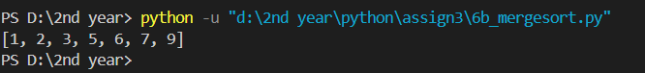

# **6c**

def min(a,p):

m=[]

m.append(a[p])

m.append(p)

for i in range(p,len(a)):

if m[0]>a[i]:

m[0]=a[i]

m[1]=i

return m

def selection_sort(a):

for k in range(0,len(a)):

mi=min(a,k)

t=a[k]

a[k]=a[mi[1]]

a[mi[1]]=t

a=[1,6,3,9,2,7,5]

selection_sort(a)

print(a)

Output:

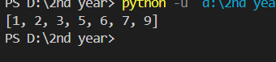

# **6d**

def insertion_sort(a):

for j in range(1,len(a)):

key=a[j]

i=j-1

while (i>=0 and a[i]>key):

a[i+1]=a[i]

i=i-1

a[i+1]=key

a=[1,6,3,9,2,7,5]

insertion_sort(a)

print(a)

Ouput:

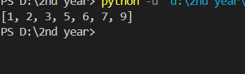

# **Using switch case:**

def buble_sort(a,n):

for k in range(0,n):

ptr=0

while ptr<n-k-1:

if a[ptr]>a[ptr+1]:

t=a[ptr]

a[ptr]=a[ptr+1]

a[ptr+1]=t

ptr+=1

def merg_sort(a,p,q,r):

n1=q-p+1

n2=r-q

L=a[p:q+1]

R=a[q+1:r+1]

L.append(float('inf'))

R.append(float('inf'))

i=0

j=0

for k in range(p,r+1):

if L[i]>R[j]:

a[k]=R[j]

j+=1

else:

a[k]=L[i]

i+=1

def merg(a,p,r):

if p<r:

q=(p+r)//2

merg(a,p,q)

merg(a,q+1,r)

merg_sort(a,p,q,r)

def min(a,p):

m=[]

m.append(a[p])

m.append(p)

for i in range(p,len(a)):

if m[0]>a[i]:

m[0]=a[i]

m[1]=i

return m

def selection_sort(a):

for k in range(0,len(a)):

mi=min(a,k)

t=a[k]

a[k]=a[mi[1]]

a[mi[1]]=t

def insertion_sort(a):

for j in range(1,len(a)):

key=a[j]

i=j-1

while (i>=0 and a[i]>key):

a[i+1]=a[i]

i=i-1

a[i+1]=key

def sort(a):

num=int(input("enter the number u want to do the sort through the number: "))

match (num):

case 1:

buble_sort(a,len(a))

print(a)

case 2:

merg(a,0,len(a)-1)

print(a)

case 3:

selection_sort(a)

print(a)

case 4:

insertion_sort(a)

print(a)

a=[1,6,3,9,2,7,5]

print("enter the number through which u want to use the sort method:")

print("1.bubblesort")

print("2.mergesort")

print("3.selectionsort")

print("4.insertionsort")

sort(a)

Ouput:

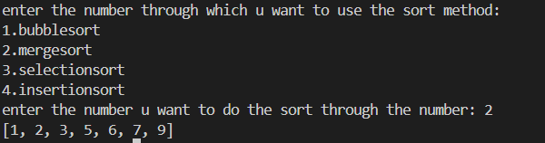

# **1**

def factorial(n):

if n==0:

return 1

else:

return factorial(n-1)*n

a=[2,6,8,4,7,9,15,17]

for i in range(0,len(a)):

if i!=len(a)-1:

print(factorial(a[i]),end=",")

else:

print(factorial(a[i]))

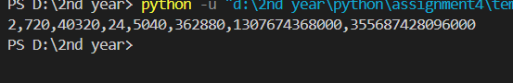

# **2**

a=input("enter the string: ")

b=a.split(",")

l=[]

for i in range(0,len(b)):

l.append(int(b[i]))

t=tuple(l)

print(l)

print(t)

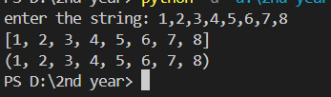

# **3**

from math import sqrt

C,H=50,30

D=input("enter the number in given format: ")

d=D.split(",")

q=[]

for i in range(0,len(d)):

x=sqrt((2*C*int(d[i]))/H)

q.append(x)

for i in range(0,len(q)):

if i!=len(q)-1:

print(int(q[i]),end=",")

else:

print(int(q[i]))

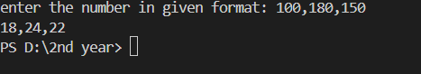

# **4**

a=input("enter the string: ")

b=a.split(",")

l=[]

k=[]

for j in range(0,len(b)):

for i in range(0,len(b[j])):

l.append(ord(b[j][i]))

k.append(l)

l=[]

k.sort()

print(k)



# **5**

def bin_to_deci(a):

c,i,r=0,0,0

while a>0:

k=a%10

c=c+(2**i)*k

a=a//10

i+=1

return c

a=(input("enter the number: "))

b=a.split(",")

deci=[]

for i in range(0,len(b)):

k=bin_to_deci(int(b[i]))

if k%5==0:

deci.append(b[i])

print(deci)



# **6**

a=[[5,6],[4,7,10,17]]

b=[tuple([j]) for i in a for j in i]

print(b)



# **8**

from math import sqrt

u=int(input("enter the movement for up: "))

d=int(input("enter the movement for down: "))

l=int(input("enter the movement for left: "))

r=int(input("enter the movement for right: "))

a=(0,0)

d=sqrt((u-d+a[0])**2+(l-r+a[1])**2)

k=int(d)

print(k)

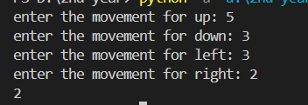

# 

# **10**

l=[(15,6),(16,7),(16,8),(16,10),(17,13)]

b=[]

c=[]

k=[]

for i in range(0,len(l)):

if l[i][0] not in k:

k.append(l[i][0])

b.append(l[i][0])

b.append(l[i][1])

for j in range(0,len(l)):

d=l[i][0]

if i!=j and d==l[j][0]:

b.append(l[j][1])

c.append(tuple(b))

b=[]

print(c)

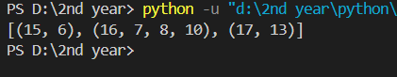

Havent done the 7th and 9th problem